Thank you for your participation.

The aim of this study is to understand consumer preferences for automated vehicles (AVs). You will be asked to answer some questions that ask you about your attitudes towards AVs

Please read the background information provided on AVs to be able to understand and answer the questions in the survey.

**Below is a table depicting 6 possible types of vehicles. The different types are based on how many driving tasks are controlled by the human driver (‘HUMAN’) versus the self-driving system (‘MACHINE’).**

 In level 1, the human controls all driving tasks, whereas in level 6, the machine controls all driving tasks. The levels in-between differ in which driving tasks are controlled by the human versus the machine.

We will be asking you to answer some questions based on the AV brand as shown below:

**Version 1: Without Car photo**

Name: AEON **AUTOPILOT**

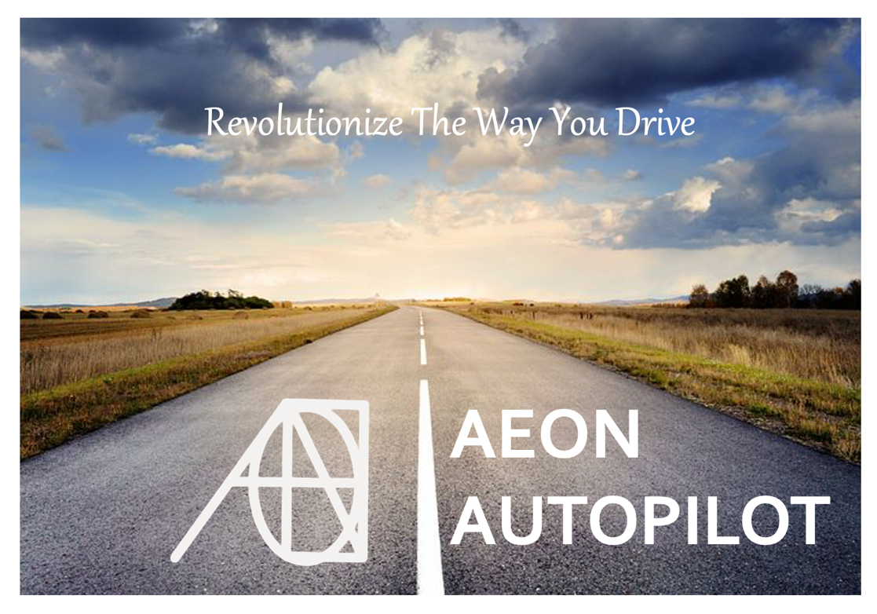

**Version 2: With car photo**

Name: **AEON** **AUTOPILOT**

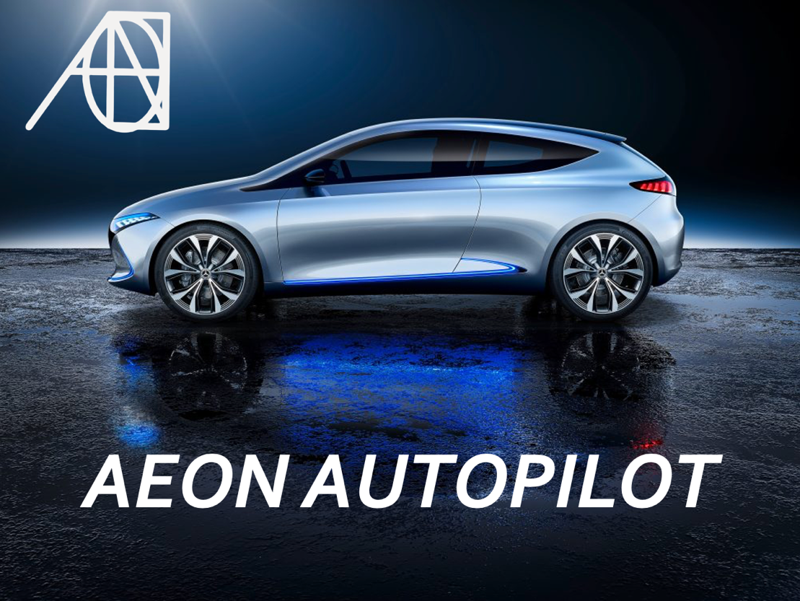

Second option is not to show any image but simply the name.

Consider the following AV car/program:

**AEON AUTOPILOT**

**What is your perceived level of automation for the AUTOPILOT?**

* **1**
* **2**
* **3**
* **4**
* **5**
* **6**

**Perceived ease of use** (Scale: 1-100)

Rate how easy you think it would be to learn how to drive the **AUTOPILOT**?

Rate how easy you think it would be to learn how to control the **AUTOPILOT**?

Rate how easy you think it would be to understand the **AUTOPILOT**

Rate how easy you think it would be to misunderstand/misinterpret the **AUTOPILOT**

**Perceived value** (Scale: 1-100)

Rate the quality of the **AUTOPILOT**

Rate how much you would enjoy using the **AUTOPILOT**

Rate how much you think the **AUTOPILOT** will improve your social standing/impression

Rate how economical you think purchasing the **AUTOPILOT** would be